**Project Report Template**

1. **INTRODUCTION**
   1. **Overview**

**A CRM is a customer centric system that can help education professionals nurture relationships with prospects and enrollees , produce data drive insights to illustrate progress towards goals and streamline their admissions and marketing initiatives to save time and effort.**

**1.2 purpose**

**A CRM is a system that helps schools manage the entire lifecycle of a potential customer sometimes also referred to as a lead .With a CRM ,you can track and store the data that’s important to your operation , all in one easy-to-access place.**

**2 PROBLEM DEFINITON AND DESIGN THINKING**

**2.1 EMPATHY MAP**

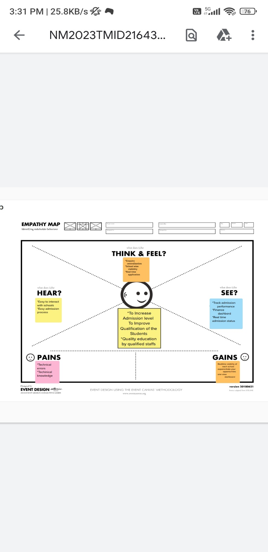

* 1. **Ideation and brainstorming Map**

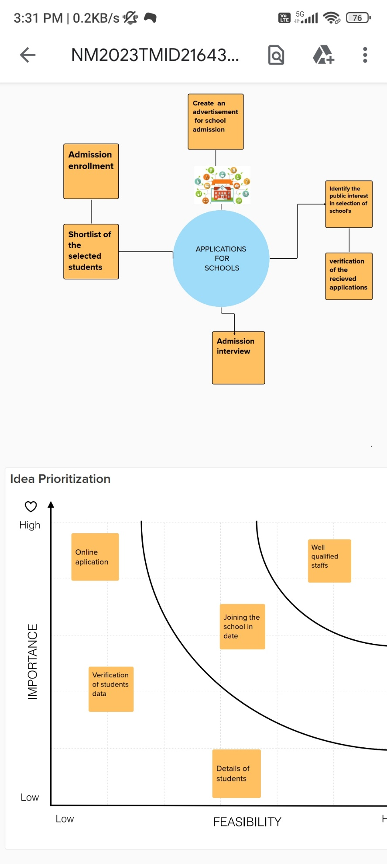

3 RESULT

3.1 DATA MODEL

|  |  |  |
| --- | --- | --- |
| OBJECT NAME | FIELDS IN THE OBJECT |  |
| OBJ 1 SCHOOL | FIELD LABEL | DATA TYPE |
|  | Address | Text area |
| OBJ 2 STUDENTS | FIELD LABEL | DATA TYPE |

|  |  |  |  |
| --- | --- | --- | --- |
|  | Phone number | Phone | |
| **OBJ 3 PARENT** | **FIELD LABEL** | **DATA TYPE** | |
|  | Parent address | Text area |  |
|  |  |  | |

3.2 ACTIVITY AND SCREENSHOT

CREATING DEVELOPER ACCOUNT

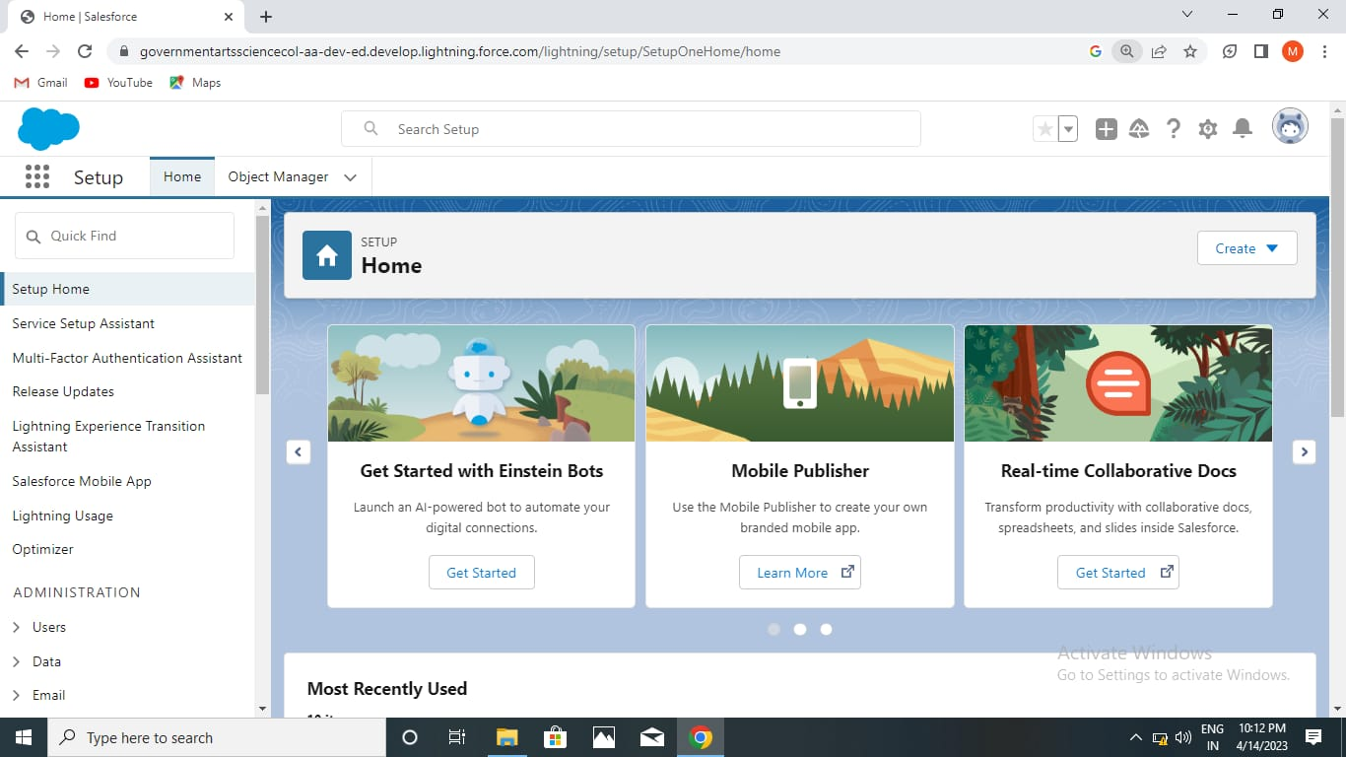

CREATION OF SCHOOL OBJECT

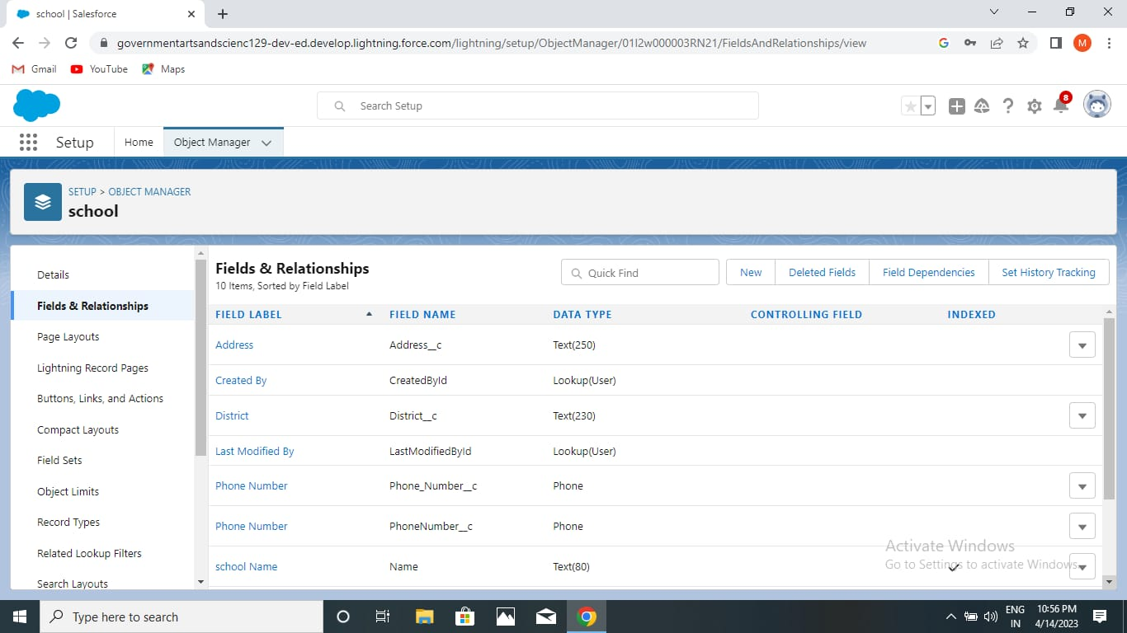

CREAION OF STUDENT OBJECT

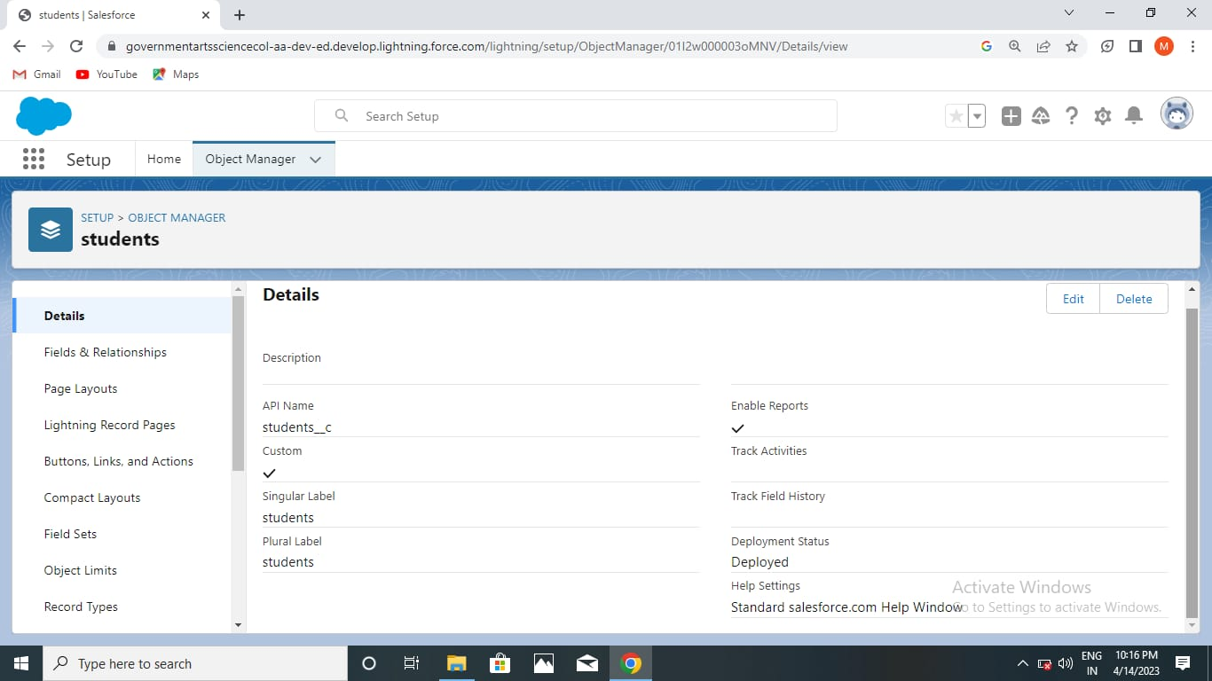

CREATION OF PARENT OBJECT

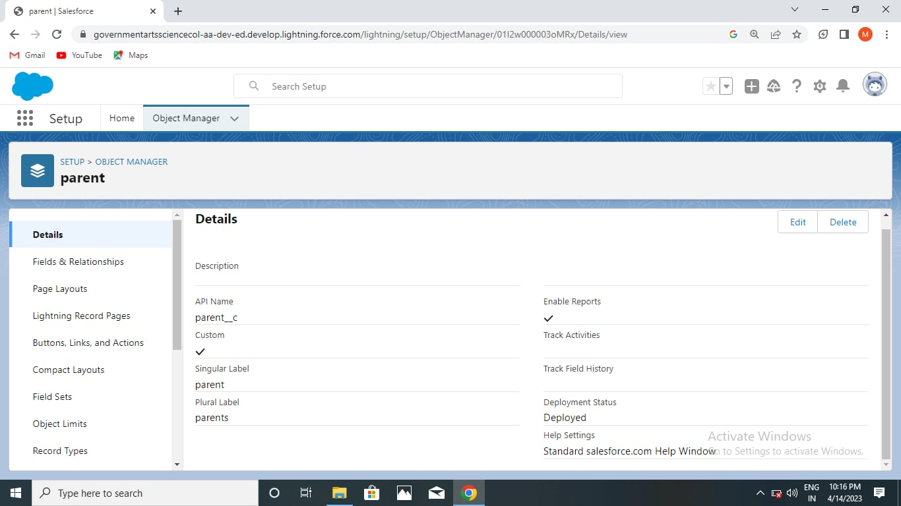

CREATION OF FIELDS FOR THE SCHOL OBJECTS



CREATION OF FIELDS FOR STUDENT OBJECT

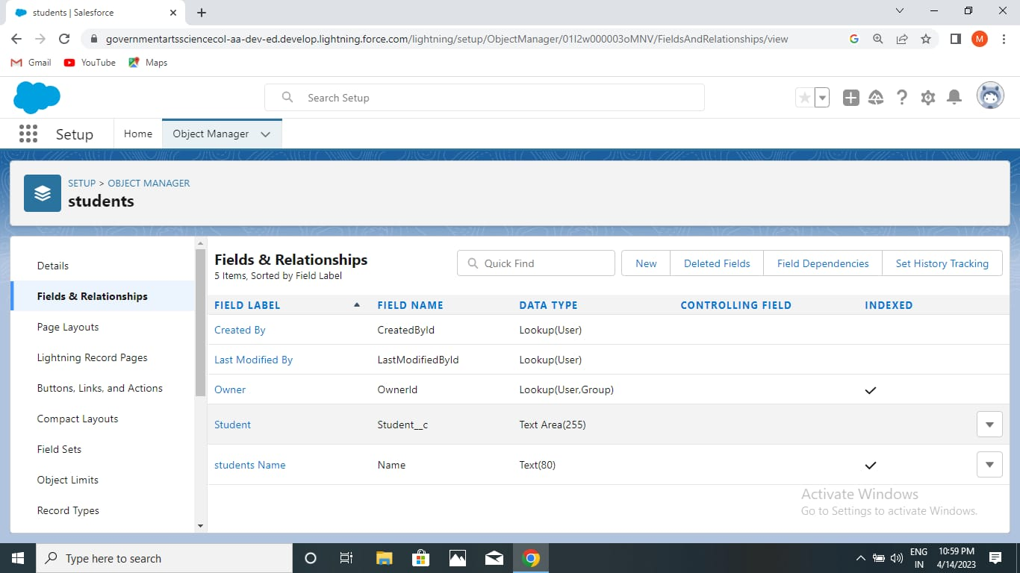

CREATION OF FIELDS FOR PARENT OBJECT

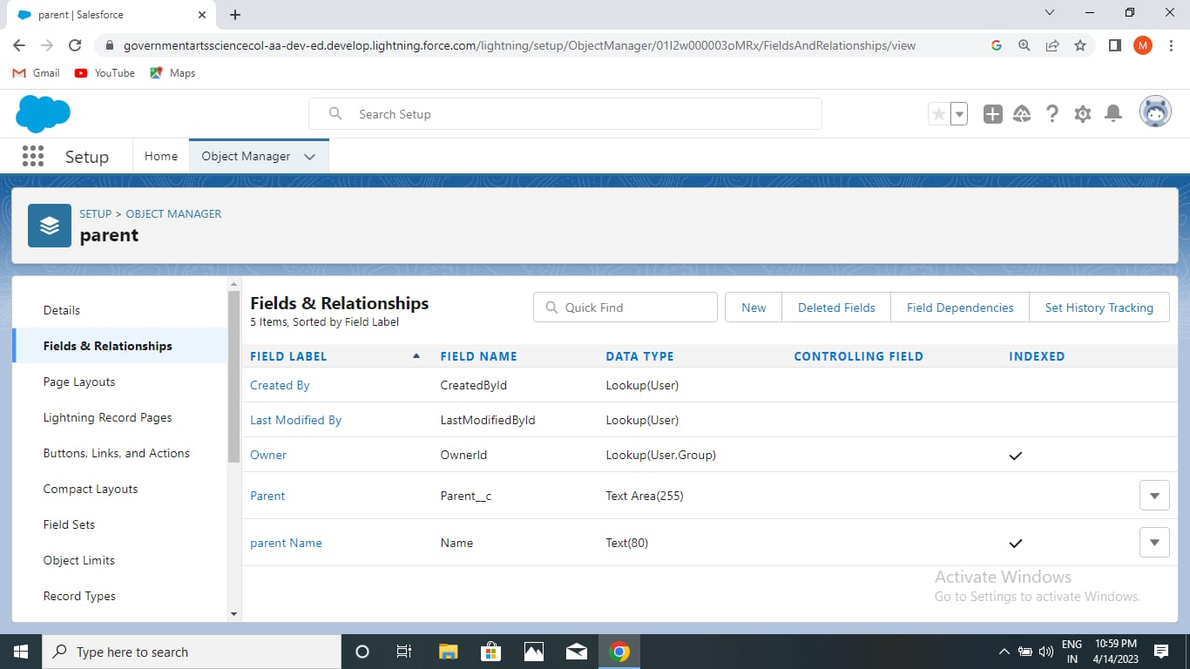

CREATION ON PROFILE

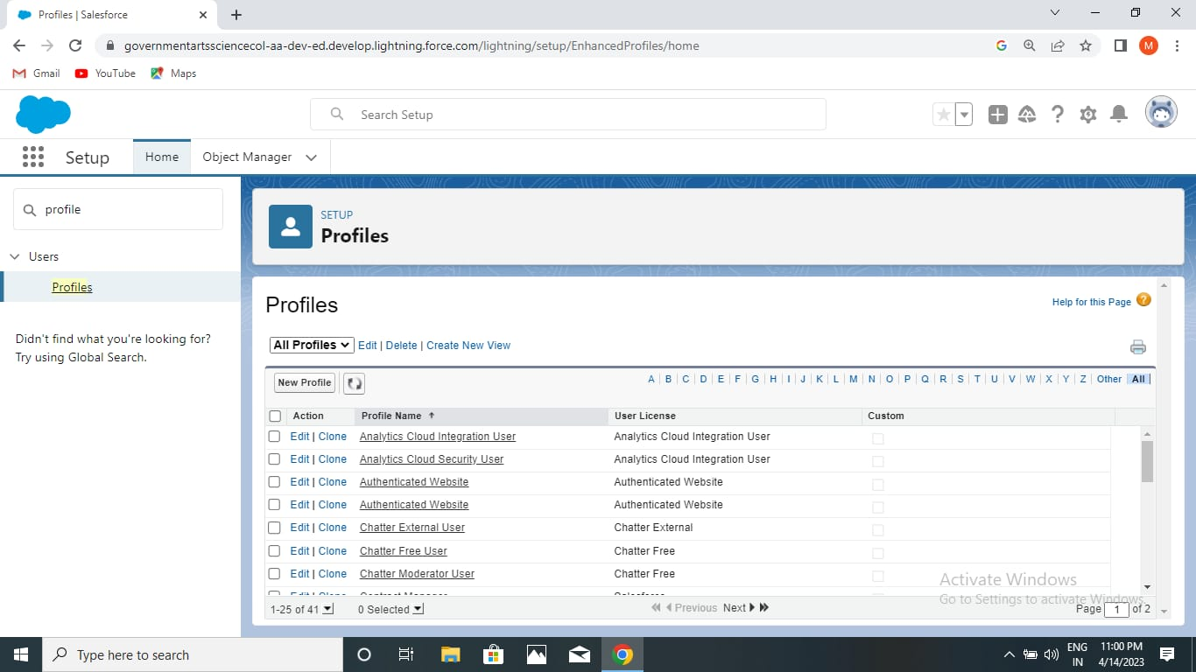

CREATING A USERS

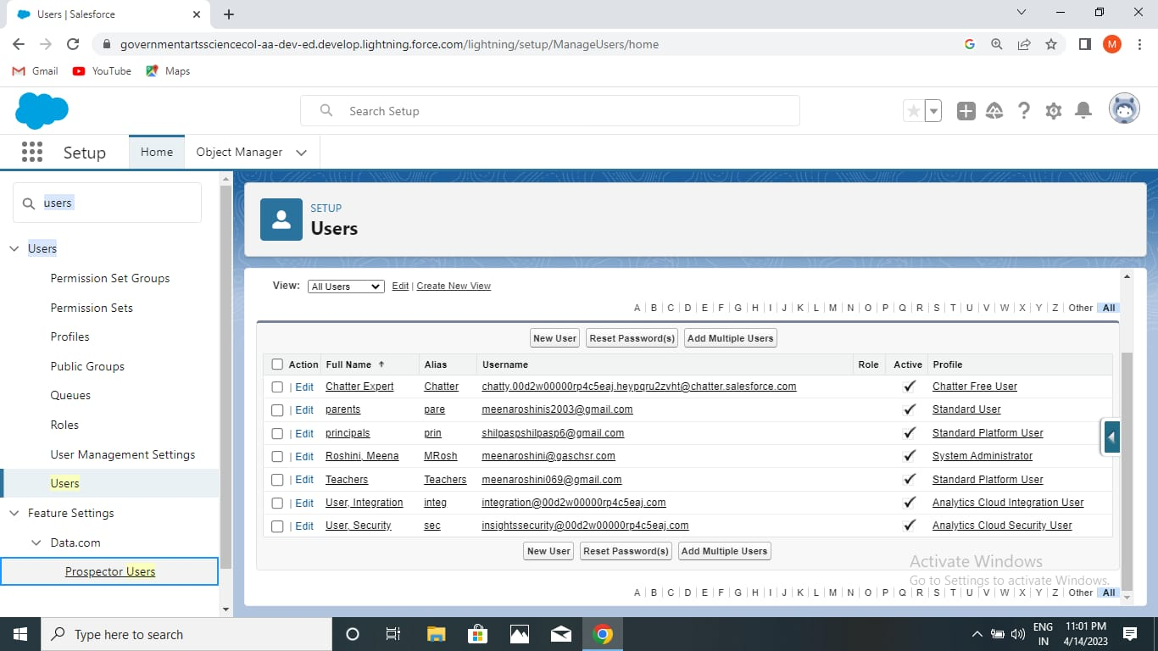

PERMISSION SETS

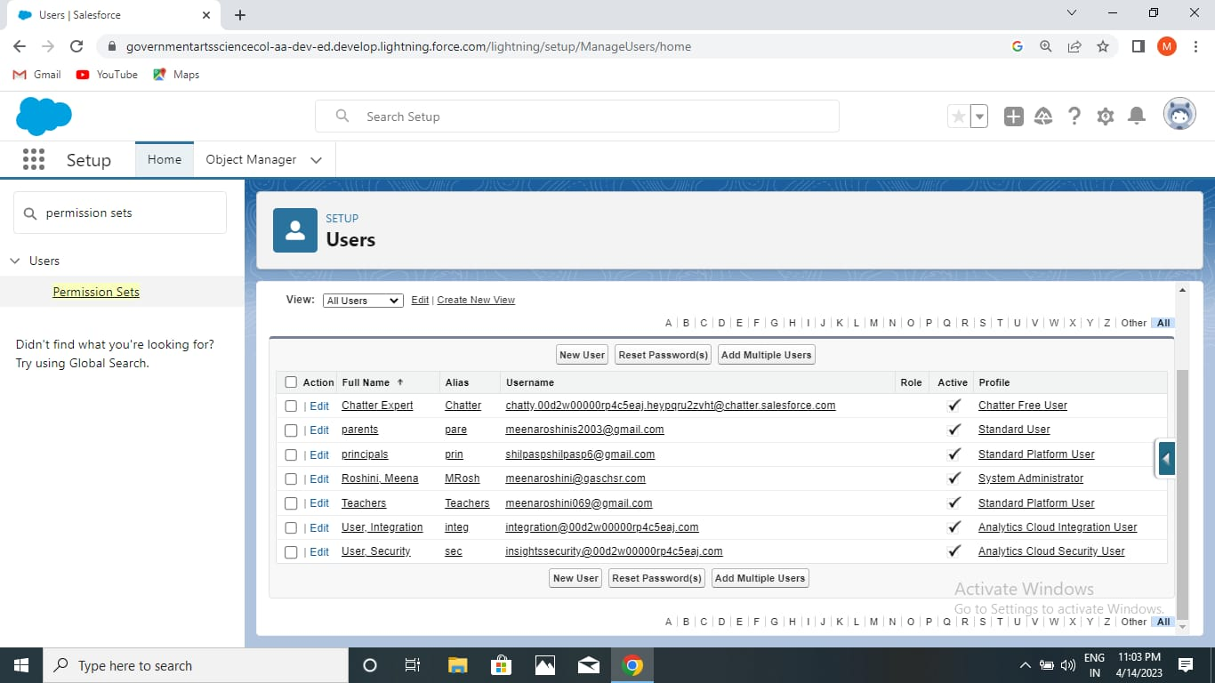

REPORT:

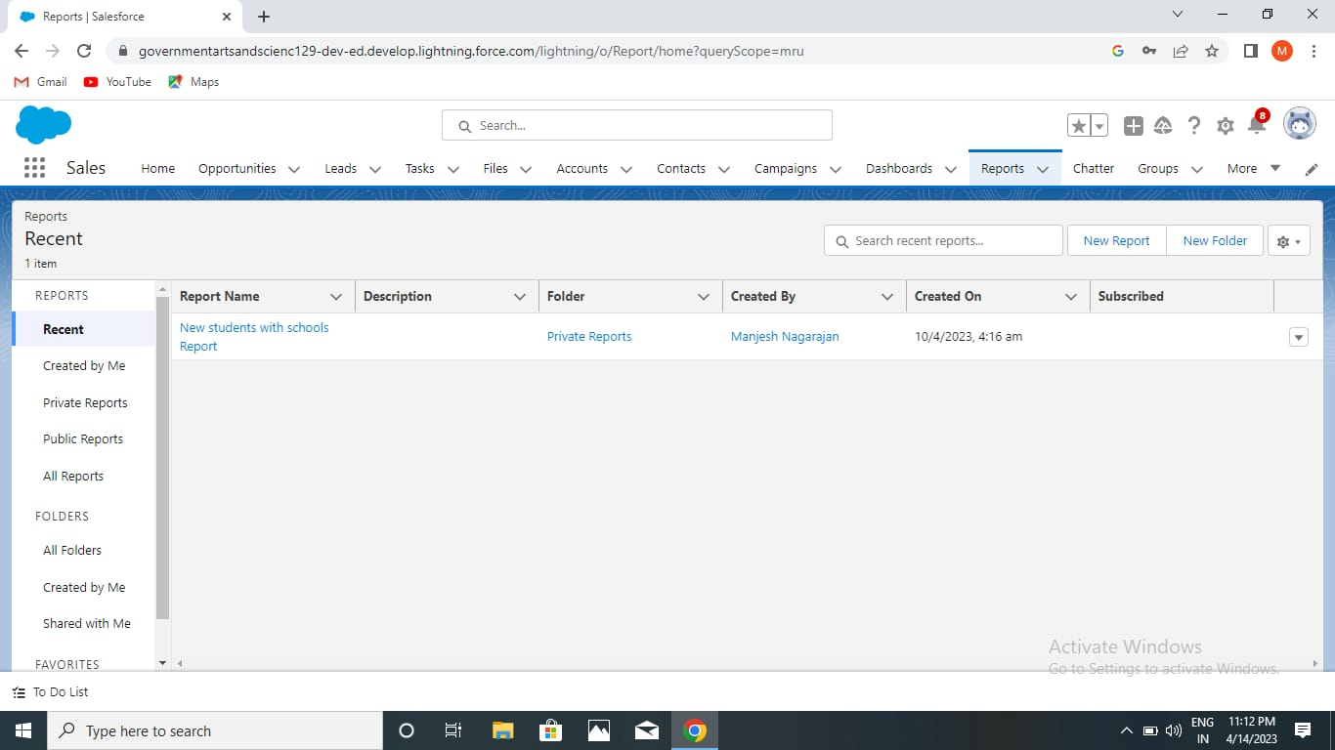

1. TRAIL PROFILE PUBLIC URL

TEAM LEAD - <https://trailblazer.me/id/m2106>

TEAM MEMBER 1-<https://trailblazer.me/id/ssrinivas333>

TEAM MEMBER 2- <https://trailblazer.me/id/na144>

TEAM MEMBER 3- <https://trailblazer.me/id/sroshini5>

1. ADVANTAGES AND DISADVANTAGES

AVANTAGES;

1. Beneficial for the different departments or teams of the business
2. customer are engaged across multiple channel
3. provide sreamline operations
4. improve customer service
5. data miming

DISADVANTAGES

1 A costly project

1. loss of collected information or record
2. not suitable for every business
3. it eliminates the human elements
4. centralized data is at stake

APPLICATIONS

1 SCHOOL and COLLEGE management are administration

CONCLUSION

CRM application is a business based on trust and value.

FUTURE SCOPE

1 Module for employee recruitment

2 Web module for web interface